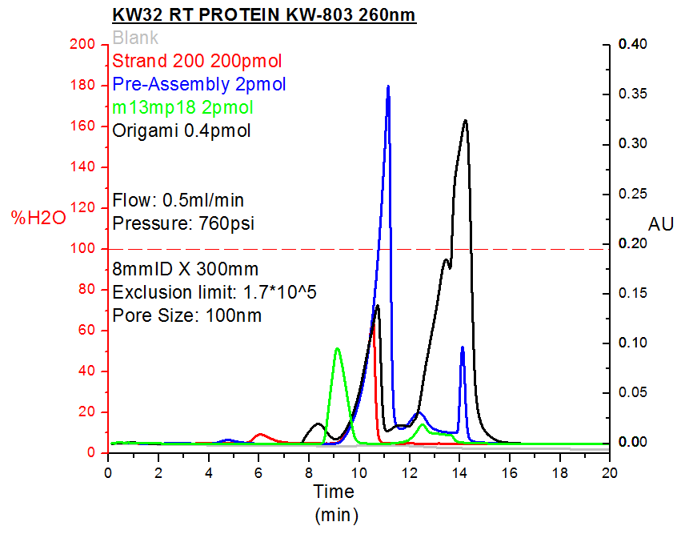

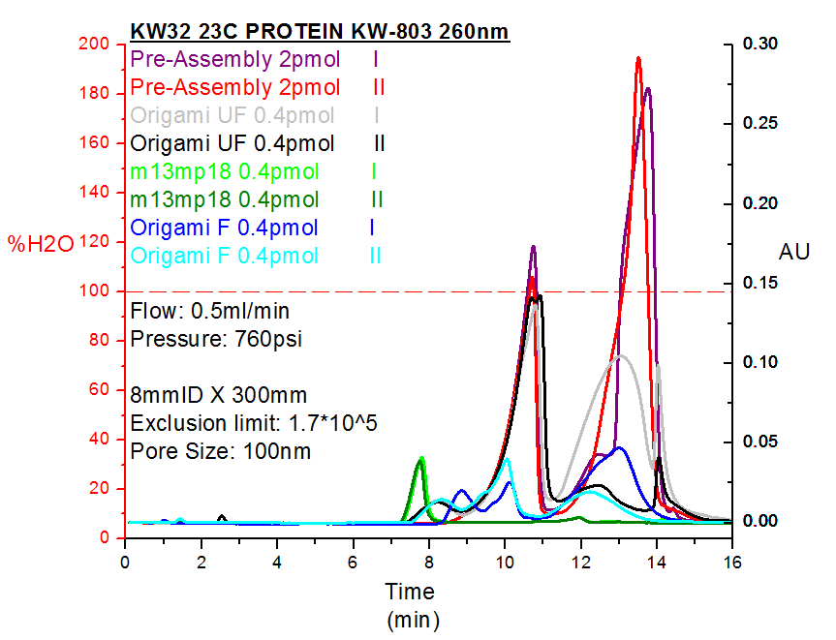

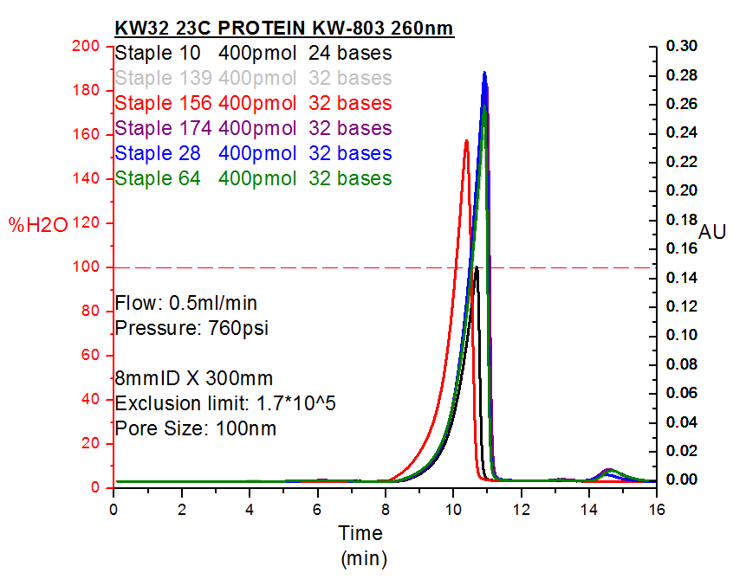

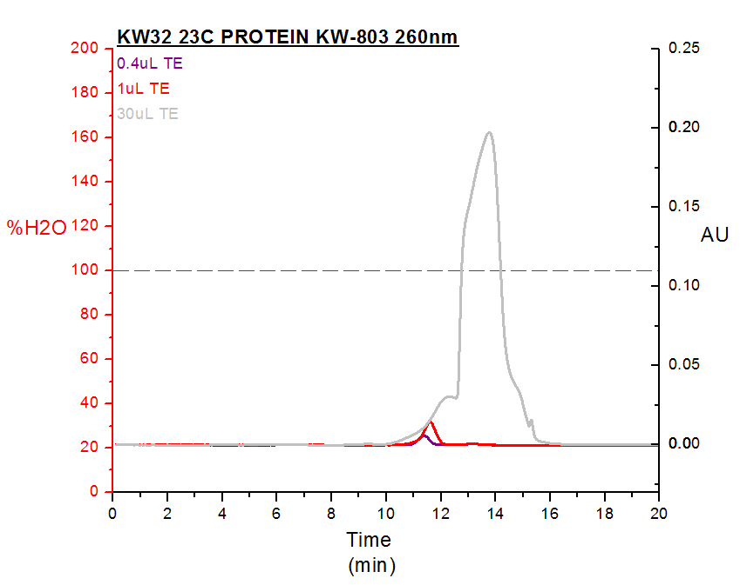

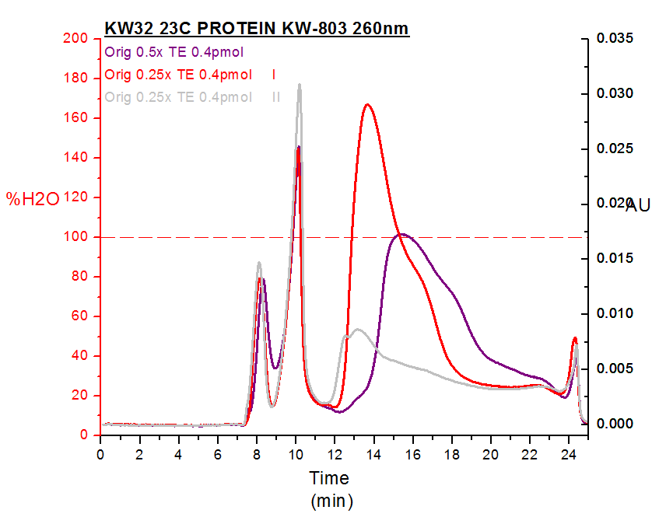

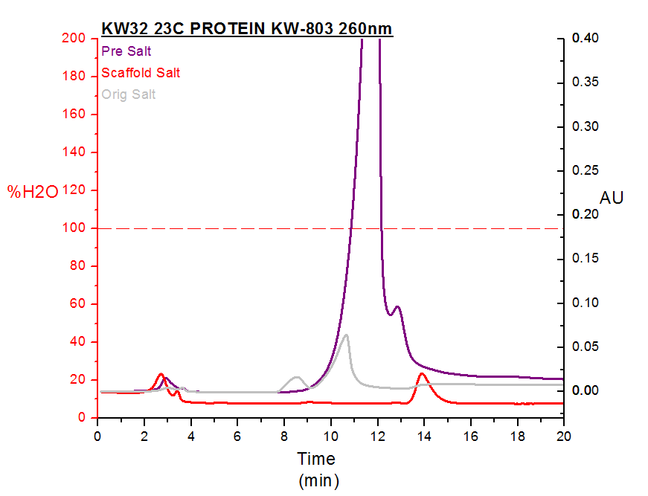

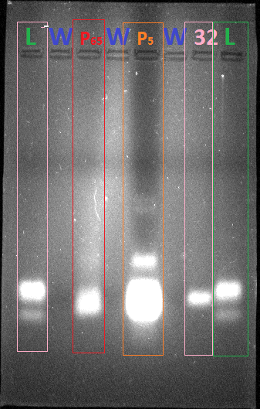

L – Ladder Staple 28 (32), 10 (24), 20 (40)

W- Water

P65 – Pre Assembly 65nM

P5 – Pre Assembly 6uM

32 - Staple 28 (32)

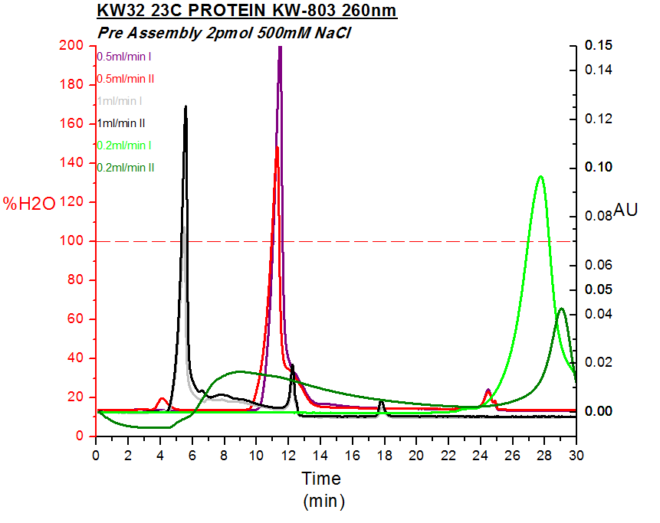

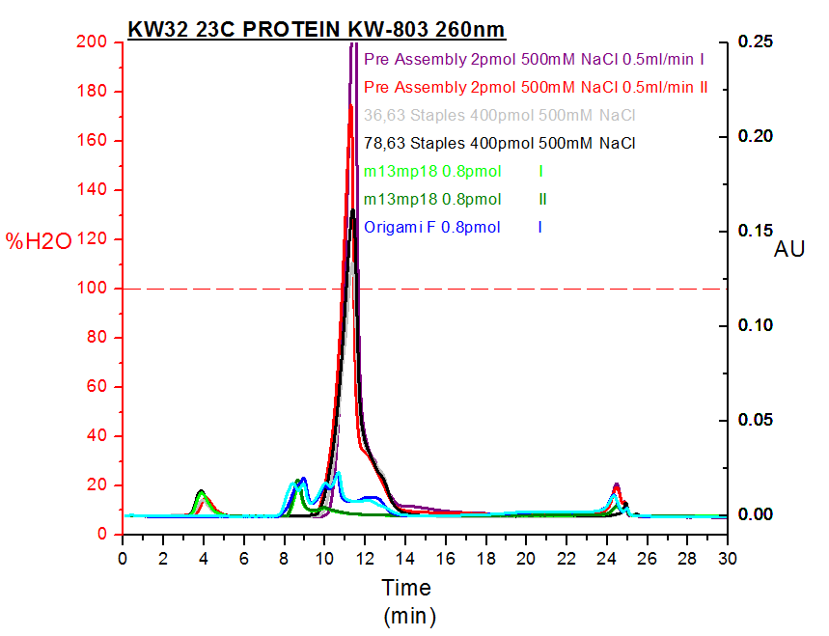

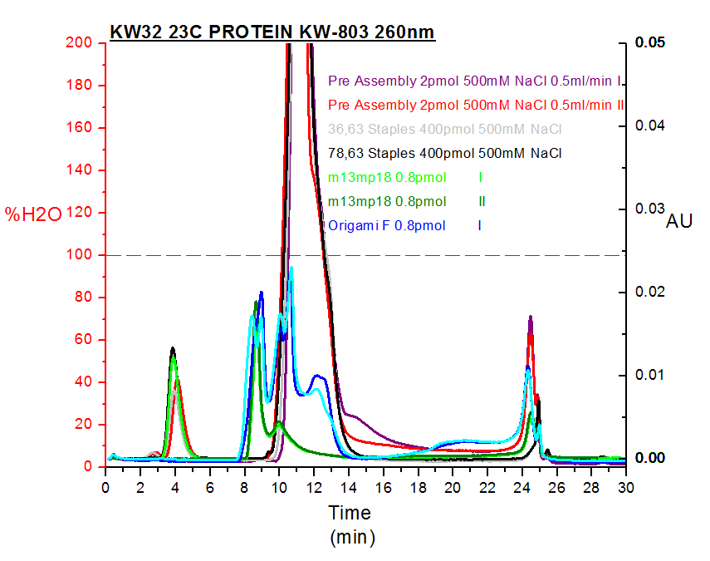

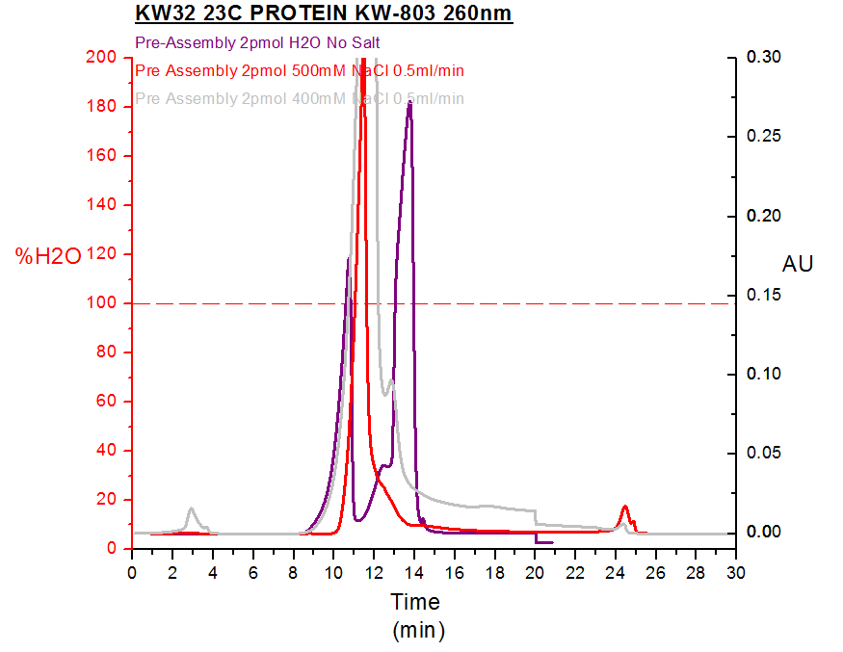

**Column: Protein KW-803 pore size 100nm**

**Running Buffer: TEAA 1x (Triethylammonium acetate 0.1M) 0.5ml/min**

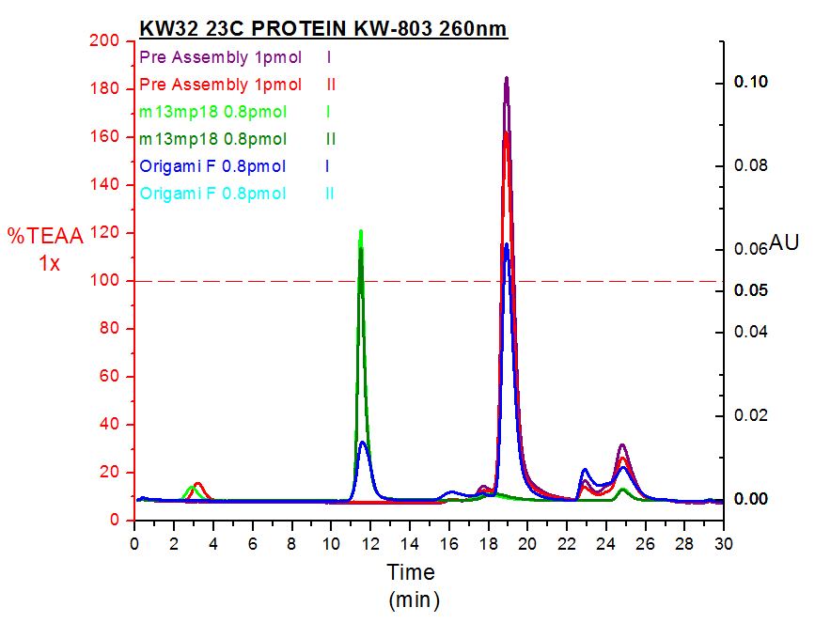**Sample: Add TEAA to 100uL in volume**

**Pre-Assembly – 0.2uL TE**

**M13mp18 – 2uL TE**

**Origami/Dimer – 10uL TE**

**250mM NaCl**

Not DNA

**Column: Protein KW-803 pore size 100nm**

**Running Buffer: TEAA 1x 500mM NaCl (Triethylammonium acetate 0.1M) 0.5ml/min**

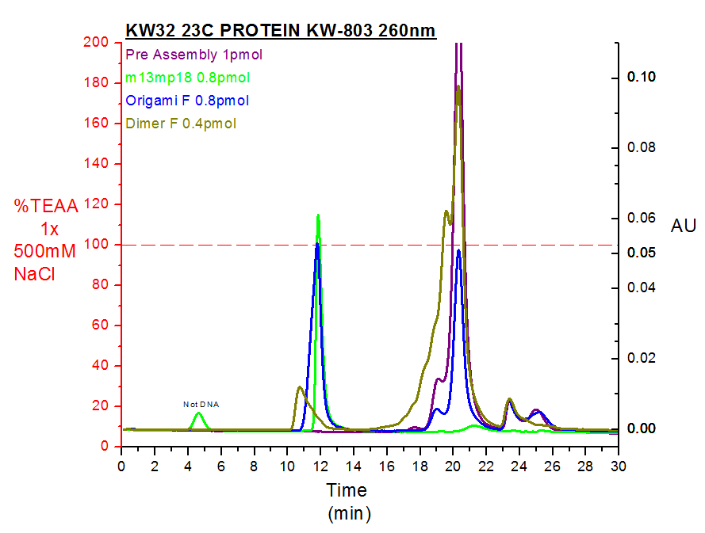**Sample: Add TEAA to 100uL in volume**

**Pre-Assembly – 0.2uL TE**

**M13mp18 – 2uL TE**

**Origami/Dimer – 10uL TE**

**250mM NaCl**

**Column: Asahipak GS-520 HQ pore size 200nm (ION EXCHANGE)**

**Running Buffer: TEAA 1x 500mM NaCl Gradient (Triethylammonium acetate 0.1M) 0.5ml/min**

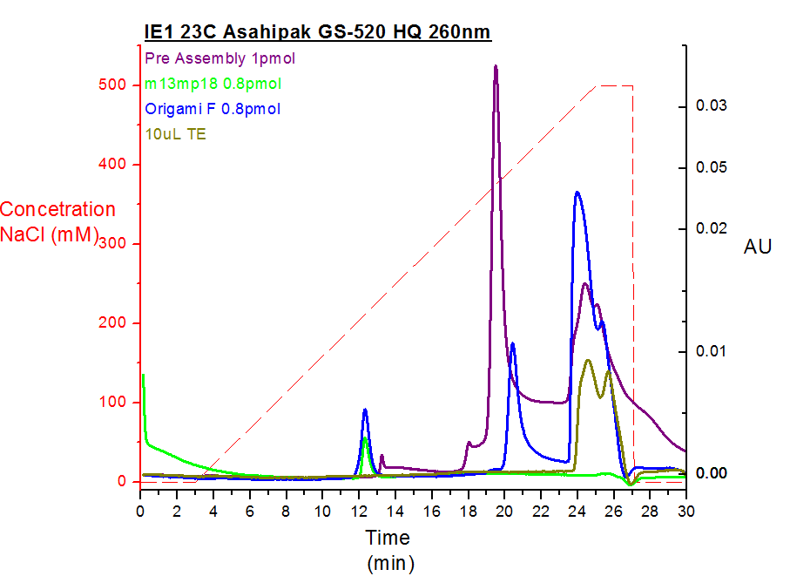**Sample: Add TEAA to 100uL in volume**

**Pre-Assembly – 0.2uL TE**

**M13mp18 – 2uL TE**

**Origami/Dimer – 10uL TE**

**250mM NaCl**